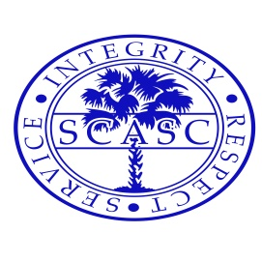

The Gavel
May 2019
Published by the South Carolina Association of Student Councils
Bonita Guram, Executive Director Roger Mize, Assistant Executive Director

Riley Wasse elected next SCASC President
Wade Hampton High School to Host
2020 State Convention
Over 700 delegates and advisors traveled to Chapin High School for the 71st Annual SCASC Convention, March 29-31, 2019. The theme of the convention was “Oh Say Can You Lead”. This theme focused on being American. On Friday registration opened at 4:00 and included many types of fun activities. The opening general session included introductions of candidates, presentation of the honor council award winners, state officer’s one minute speeches, entertainment from Aratae, an awesome student band, and a keynote address from Lance Allred. Mr. Allred is a professional basketball player who lives with the challenge of being deaf. He gave us insight on how to continue to work toward our goals in spite of life challenges. The first general session was followed by district meetings, group mixers, and a dance party at the stadium to do the State Dance “The Shag”. The advisors spent part of Friday evening judging the project awards and enjoying Chapin hospitality.
On Saturday, the second general session featured Kyle Willkom who shared lots of ideas about life and leadership. Mr. Willkom used his music to entertain and motivated the students to work together and to find strengths in themselves and their peers. The Terry McCoy Award winners were announced during the second general session. After the general session, the students attended workshops while the advisors met in the media center. During the advisors’ meeting, Roger Mize was elected the SCASC Assistant Executive Director. District elections and an old fashioned American cookout finished out Saturday afternoon.
When the students returned to the school on Saturday evening, they attended a banquet and awards ceremony. Project and scrapbook awards were presented and Ms. Amanda Pinson was awarded the 2019 SCASC advisor of the year. After the banquet, the students enjoyed a dance.
During the third general session on Sunday, state officer candidates presented speeches and votes were cast. A year in review video and the announcement of election results concluded the convention.

Congratulations to Banks Todd, Billie Williams, Roger Mize and the entire Chapin High School student council for such a wonderful and successful convention.

Thank you for all your organization, hard work and opportunities to enhance our leadership skills!

Congratulations to the students, advisors and school student councils who received honors and awards at the state convention. See the list of award winners below.
Honor Council
Award 2019

Airport High School | Gold
Aynor High | Silver
Blythewood High School | Gold
Calhoun County High School | Gold
Cane Bay High School | Gold
Chapin High School | Gold
Colleton County High School | Gold
Crescent High School | Gold
Easley High School | Gold
Fort Dorchester High School | Gold
Laurens District 55 High | Gold
Mid-Carolina High School | Bronze
Newberry High School | Gold
Pickens High School | Gold
R.B. Stall High School | Gold
Richland Northeast High | Gold
Ridge View High School | Gold
Rock Hill High School | Bronze
Spring Hill High School | Gold
Sumter High School | Gold
Travelers Rest High School | Gold
Waccamaw High School | Gold
Wade Hampton High | Gold
Westwood High School | Gold

Terry McCoy Hall of Fame Winners 2019

Jordan Abney | Gilbert High School
Savannah Azize | Westwood High School
Mary Kathryn Ballentine | Blythewood High School
Bladen Bates | Wade Hampton High
Jack Bauer | CrossRoads Intermediate
Chloey Bell | Easley High School
McCuen Bland | Chapin High School
Star Blevins | Green Sea Floyds HS
Emma Bridges | Bamberg-Ehrhardt HS
Isaiah Brooks | Sumter High School
Maddie Buisch | Greer Middle College Charter HS
Taylor Burger | Powdersville High
Holly Buxton | Dutch Fork High School
Chase Donaldson | Calhoun County High
Thomas Frank | Colleton County High
Emilie Glenn | Crescent High School
Margaret Greene | Richland Northeast High
Brina & Karlie Hayes | Dacusville Middle
Da'Myesha Haynes | R.B. Stall High School
Mary Catherine Horton | Waccamaw High School
Mallorie Jaeger | Newberry High School
Ramey Jenkins | Laurens District 55 High
Sarah Grace Jerkins | Gilbert Middle School
Micah Jordan | Pickens High School
Chanlan Ann Kasa | Travelers Rest High
Sophie Kastenholtz | Fort Dorchester High
Katie Kyzer | Airport High School
Keith Moore Jr. | Carvers Bay Middle
William Murray | Mid-Carolina High
Keshav Nair | Spring Valley High
Lilly Margaret O'Leary | Dutch Fork Middle
Claire Outz | Spring Hill High School
Alissa Pressley | Irmo High School
Kynan Robinson | TL Hanna High
Loren Short | Northwest Middle School
Kara Singleton | Aynor Hgh School
Otiana Thompson | Ridge View High School
Banks Todd | Chapin High School
Heather Varn | Manning High
Gracyn Whitaker | Pine Ridge Middle

Project Winners 2019
Leadership Activities

Middle Level
1st: Carvers Bay MS (I Too Have a Dream)

1A-3A
1st: Crescent HS (Middle School Leadership Day)
2nd: Manning HS (MHS Leadership Summit)
3rd: Newberry HS (Orientation Ambassadors)

4A/5A
1st: Travelers Rest HS
(Not Your Average Summer Planning Retreat)
2nd: Easley HS (Student Council Family Christmas)

School Spirit

Middle Level
1st: Pine Ridge MS (PARTY Party, Party is on our side)
2nd: Dutch Fork MS (Pink-Green out Pep Rally)

1A-3A
1st: Newberry HS (Jingle with Joy)
2nd: Waccamaw High (Warrior Olympics)

4A/5A
1st: Easley HS (Covering the School in Love)
2nd: Chapin (Eagle Fest)
3rd: Ridge View (Bash the Bengal)

Recognition
Middle Level
1st: Dutch Fork MS (First Friday)
2nd: Pine Ridge MS (Just a Morsel of Gratitude)
3rd: Dacusville MS
(What Would You Do for a Klondike Bar?)

1A-3A
1st: Gilbert HS (Souper Teacher)
2nd: Crescent HS (Wall of Kindness)
3rd: Waccamaw HS (Senior Signing)

4A/5A
1st: Ridge View HS (We Got Your Back Dr. Mack)
2nd: Blythewood HS (Little Shop of Horrors)
3rd: Chapin HS (Senior Pledge Assembly)

Community Service

Middle Level
1st: Carvers Bay MS (Courage to Fight Cancer)

1A-3A
1st: Gilbert HS (Tomohawk Fest)
2nd: Bamberg-Ehrhardht HS(Red Raider Book Blitz)
3rd: Mid Carolina HS (Military Care Packages)

4A/5A
1st: Airport HS (Reading Buddies)
2nd: Wando HS (Wandothon)
3rd: Wade Hampton HS (Clement’s Kindness)

Recreational Activities

1A-3A
1st: Manning HS ( Fall Festival Carnival)
2nd: Bamberg-Ehrhardht HS
(Getting to Know student Leaders Through Fun and Fellowship)
3rd: Waccamaw HS (Winter Formal)

4A/5A
1st: Colleton County HS (Special Love)
2nd: Blythewood HS (Hallway Hopscotch)
3rd Wade Hampton HS (Midnight Jam)

Project Winners: If your school won for one of the projects, please email a copy or description of the project to scascguram@gmail.com. We want to make them available to share with other advisor.

School Pride
Middle Level
1st: Dacusville MS (Spread the Love)
2nd: Northwest MS (Tory Days)

1A-3A
1st: Bamberg-Ehrhardht HS (Senior Crowning)

4A/5A
1st: Blythewood HS (Black History Month Banner)
2nd: Spring Valley HS(Be the Change)
3rd: Laurens Dist. 55 HS (Laurens Against Violence)

Fundraising
Middle Level
1st: Northwest Middle School
(Autism Awareness Week)

1A-3A
1st: Mid Carolina High School (Boo Fest)
2nd: Gilbert High School (Canteen Buy Out)

4A/5A
1st: Airport HS for Camp Chemo

Videos
1A-3A
1st: Mid Carolina HS (We are Family)
2nd: Crescent HS (Mr. Crescent)
4A/5A
1st: Spring Valley HS ( I am More)

School Service

Middle Level
1st: Pine Ridge MS (Let it Grow)
2nd: Dacusville MS (President’s Day Trivia)
3rd: Northeast MS (Kill the Flu)

4A/5A
1st: R B Stall HS (Mountain of Gratitude)
2nd: Westwood HS (Get Your Game On: Fresh Start)
3rd: Wade Hampton HS (Family Fun Fest)

SCASC 2019 Scrapbook Winners

4A-5A Schools Gold: Laurens District 55 High
Silver: Chapin High

1A-3A Schools Gold: Waccamaw High
Silver: Mid Carolina High

Middle School Gold: Dutch Fork Middle
Silver: Bates Middle

Advisor Awards
10 year certificate
Kristy Hood | West-Oak Middle

15 year certificates
Joy Altman | Academic Magnet High
James Barton | Fort Dorchester High
Dr. Bernadette Darby | Heyward Gibbes Middle
Mary Chorey | Sumter High

20 year certificate
Brooke Yarbrough | Laurens District 55 High

Retiring
Rebecca Goodwin | Colleton County High
Michelle Smith | Cane Bay High

5 year certificates
Sharonda Jacobs | Aiken Scholars Academy
Kim Baxley | Batesburg Leesville High
Billie Williams | Chapin High
Lisa R. Miller | Chesterfield-Ruby Middle
Michelle Woodward | Chesterfield-Ruby Middle
Brent White | CrossRoads Intermediate
Meredith Adams | Fort Mill High
Ben Tyler | Fort Mill High
Marion Jacobs | Greenville High
Charlotte Ihme | Greenville Technical Charter
Meredith Morgan | Hillcrest High
Heather Knight | Indian Land High
Hunter Ballenger | JL Mann High
Jill Ford | Palmetto High
Mike Hattan | Palmetto High
Hayden Woerner | Powdersville High
Elisha Revis | St. James High
Ellen R. Heatley | St. Matthews K-8
Dana Mitchell | Sumter High
Danette Buddin | TL Hanna High
Courtney Jackson | Wren High

SCASC 2019 High School SCASC 2019
Advisor of the Year Administrator of the Year
Amanda Pinson Dr. Cheryl Guy
(Crescent High School) (Westwood High School)

Thank you Advisors!

“You make a living by what you get. You make a life by what you give” -
Winston Churchill

South Carolina Association of Student Councils
 | 2019-2020 Executive Board
Executive Director |  | Bonita Guram | Columbia SC
Assistant Executive Director |  | Roger Mize | Chapin HS
President |  | Riley Wasse | Wade Hampton HS
Vice President |  | Emilie Glenn | Crescent HS
Recording Secretary |  | Abi Norton | Pickens HS
Corresponding Secretary |  | Kallie Richbourg | Airport HS
District 1
Chairman |  | Emma Bridges | Bamberg-Ehrhardht HS
Vice Chairman |  | Anne Mathis Thomas | Colleton County HS
District 2
Chairman |  | Donte' Coleman | Sumter HS
Vice Chairman |  | Marilize Cornwell | Sumter HS
District 3
Chairman |  | Priya Desai | Spring Hill HS
Vice Chairman |  | Emmalee Gunter | Chapin HS
2nd Vice Chairman |  | Liz Schaffer | Pine Ridge MS
District 4
Chairman |  | Johnathan Brown | Spring Valley HS
Vice Chairman |  | Yazmine Latimore | Ridge View HS
District 5
Chairman |  | Chris Hall | Travelers Rest HS
Vice Chairman |  | Brennan Koontz | Wade Hampton HS
District 6
Chairman |  | Haley Pepper | Crescent HS
Vice Chairman |  | Ella DeNicola | Mid-Carolina HS
2nd Vice Chairman |  | Mason Gibbs | Laurens Dist. 55 HS
Advisors' Association
President |  | Daniel Bailey | Airport HS
President Elect |  | Amanda Pinson | Crescent HS
Secretary |  | Brooke Yarbourgh | Laurens D55 HS
District 1 |  | Bridget Kinard | Bamberg Ehrhardht HS
District 2 |  | Dana Mitchell | Sumter HS
District 3 |  | Ryan Cole | Spring Hill HS
District 4 |  | Olisa Ashford | Spring Valley HS
District 5 |  | N. Nolen /D. McCarrell | Travelers Rest HS
District 6 |  | Amanda Pinson | Crescent HS
Host President |  | Sandy Brooks | Wade Hampton HS
Camp Coodinator |  | Amanda Pinson | Crescent HS
Travel Coodinator |  | Roger Mize | Chapin HS
Photo,Video, Publicity |  | Wendi Wimmer | Greenwood HS

From the Executive Director:

This has been another successful year for SCASC. Thank you to all the advisors and students who have worked so hard to make a difference in your schools and communities. District officers and advisors, we are grateful for all the hard work you put into your rallies and throughout your districts. Big thanks to the state officers for all your help in your specific areas. A BIG thanks to Banks Todd, Roger Mize and Billie Williams and the entire Chapin student council for giving us such a successful convention.

I look forward to working with the new state and district officers. I can already see that this will be a dedicated group. We will begin our endeavors this summer with the national conference in Pennsylvania and then the leadership camp at Cherry Grove.

Advisors, I truly appreciate all that you do for your students, schools and SCASC. Continue to let us know if we can do anything to help you and if you have ideas that will help improve the SCASC organization. I know you continue to work through the summer break, but I hope you also get a chance to relax and spend some quality time with your families and friends. I hope you have an enjoyable and restful summer.

Bonita

SCASC Membership

Remember that SCASC Membership will now run from September 1, 2019 to September 30, 2020. Membership dues are due September 1. Dues are $50 for regular membership and $60 for Palmetto membership.

You will get a membership reminder in August. Information and the link for membership will be available on the website, thegavel.org. You MUST complete the online registration for membership.

SCASC Leadership Camp 2019
Sunday July 14- Thursday July 18, 2019
Camp Cherry Grove, FFA Leadership Center
1069 FFA Circle Drive, North Myrtle Beach, SC 29582
Cost: $250 students / $150 advisors
Leadership Is My Super Power
Registration cost covers all meals from Sunday dinner through Thursday breakfast, all materials and handouts, and lodging. T-shirts will be available for $10/$15 each and the FFA staff will run a canteen for delegates to purchase snacks. Advisors will need to find lodging outside the camp grounds in order to utilize the cabin space for student delegates.

Online Registration: Opened April 22, 2019 (7:30 am). Camp registration is now closed and camp is FULL. The link and paperwork are posted on www.thegavel.org

Due Date: Paperwork and checks by Friday, May 17, 2019

What is Leadership Camp? It is designed to help council members develop their leadership skills to be a more effective officer or council member in their schools. It is a training camp. It is a place for students to learn ideas from other leaders from across the state that they can use in their own schools. It is a chance to learn silly songs that will bond friendships!

What we will cover during camp?
- Problem solving techniques: brainstorming, research, using resources effectively.
- Leadership skills: listening, responding and overcoming blocks to communication, dealing with different audiences, conducting meetings.
- Human relations skills: Keeping a group together, conflict management, increasing awareness of cultural diversity, relationships with community outside school.
- Organization skills: parliamentary procedure, agenda preparation, roles in groups, assigning tasks, delegating responsibility.
- Officer training: just what are the responsibilities of each office

A Typical Day At Camp
Delegates will be assigned to a council and will work to solve an assigned problem, create cheers and chants, develop a council skit and design a council flag. Each day, delegates will also attend skills sessions taught by our experienced staff members, meet with their council, attend electives, enjoy free time and have the opportunity to participate in a talent show, field day and camp parade. Throughout, the week delegates are able to network, make lasting friends, bond as a family and make memories that will last a lifetime.

Contact Information:
Amanda Pinson pinsonahp@gmail.com

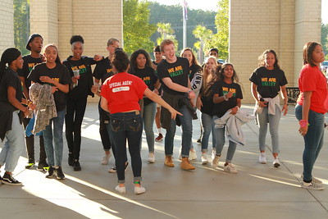
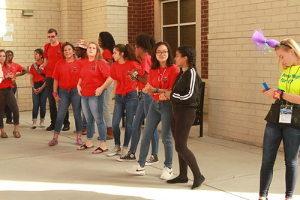
SASC Conference News
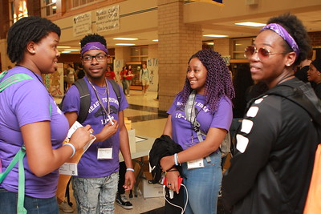
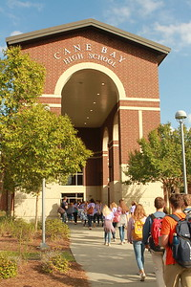
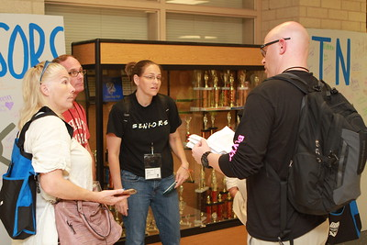
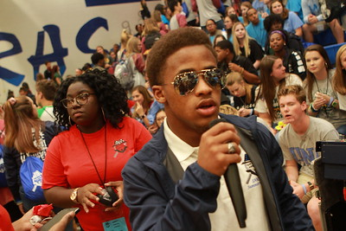
South Carolina represented well, and Cane Bay High School did an amazing job hosting the 2018 Southern Association of Student Councils Conference this past October in Summerville, SC. The theme of the conference was “Operation Leadership.” and more than 185 SCASC delegates and advisors, not counting Cane Bay, attended. The delegates attended workshops, listened to keynote speakers, and spent an evening at the SC aquarium. The South Carolina schools represented at the conference include Airport High, Bamberg-Ehrhardt High, Berkeley Middle, Blythewood High, Chapin High, Crescent High, Fort Dorchester High, Fulmer Middle, Greenwood High, Laurens District 55 High, Northwest Middle, Pickens High, RB Stall High, Ridge View High, Riverside High, Spring Hill High, SpringValley High, Stratford High, Sumter High, Travelers Rest High, Waccamaw High, Wando High and of course Cane Bay High.
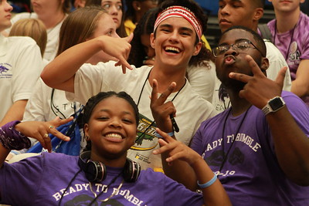
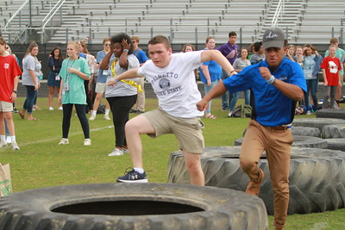
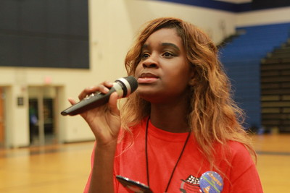
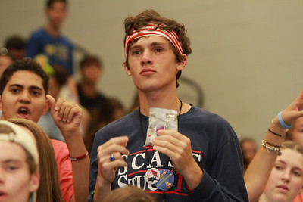
South Carolina schools lead the way during the conference. Chapin High School was elected SASC parliamentarian. Several South Carolina schools presented workshops. Several SC advisors served as project judges and South Carolina schools won awards in many project categories. Trace Wingard, from Airport High School, was awarded the SASC student of the year and Fletcher Spigner, from Blythewood High School, was awarded the SASC advisor of the year. We are so proud of the work our student councils do and are delighted these students, advisors and schools were recognized at the conference. See the list of winners below.
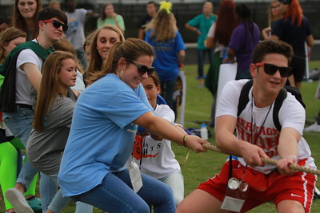

The next Southern Conference will be at Sulpher High School in Sulpher, LA, October 26-28, 2019. The theme is “Building Leadership” The cost for registration is $170.

Information about the Southern Association of Student Councils membership and the SASC Conference, are available at their website http://www.sascschools.com.
SASC Award Winners

Airport High School
Community Outreach Project, 2nd place- Reading Buddies
School Service Project, 3rd place- Holiday Blitz Drive
Trace Wingard was named the 2018 SASC Student Leader of the Year

Blythewood High School
1st Place in the Academic Incentive Project category for Senior Assembly
1st Place in the Community Service Outreach Project category for Project Connect
2nd Place in the Student Service Project category for Freshmen First
2nd Place in the Print Media Project category for Spirit Week Photo Booths
Fletcher Spigner was named the 2018 SASC Advisor of the Year

Chapin High School
2nd place for Community Service - Fundraising

Crescent High School
1st Place for Print Media project
2nd place for Environmental Awareness project.

Easley High School
1st place Poster Contest
2nd place Photography Contest
3rd place - Membership Training

Laurens District 55 High School
SASC Outstanding Leader Scholarship- Ramey Jenkins
Citizenship and Patriotism: Patriotic Day- First Place
Membership Motivation and Development: Edisto Beach Week- First Place
Student Support Project: Raiders Against Violence- 2nd Place

R.B. Stall High School
Outstanding Project in Leadership Outreach/Mentoring for our Camp LEAD project.

Wando High School
1st - School Spirit
1st - School Service
3rd - Homecoming

National Student Council Conference
The NatStuCo conference will be at South Fayette High School in McDonald, PA, June 24-26, 2019. The conference theme is “FORGING STUDENT LEADERS”. South Carolina will be attending with 12 advisors and 26 student delegates. We are looking forward to experiencing the culture of Pennsylvania, learning new leadership skills and ideas, bonding with our new officers and networking with people from many states throughout the country.

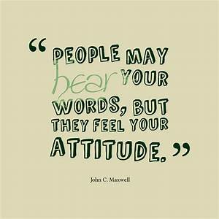
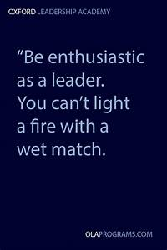
Quotes for Students
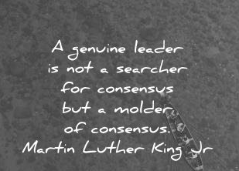

Have an awesome summer! Do It Right, Make it Big, Give it Class!!

